
NAME : VAANI JINDAL
SAP : 500119144
BATCH : 2
SUBJECT : OOPS

EXPERIMENT -6

Ques 1: Create a package named Balance containing a class Account with a method Display_Balance that displays the account balance. Write another program to import the Balance package and call the Display_Balance method from the Account class.
Code :
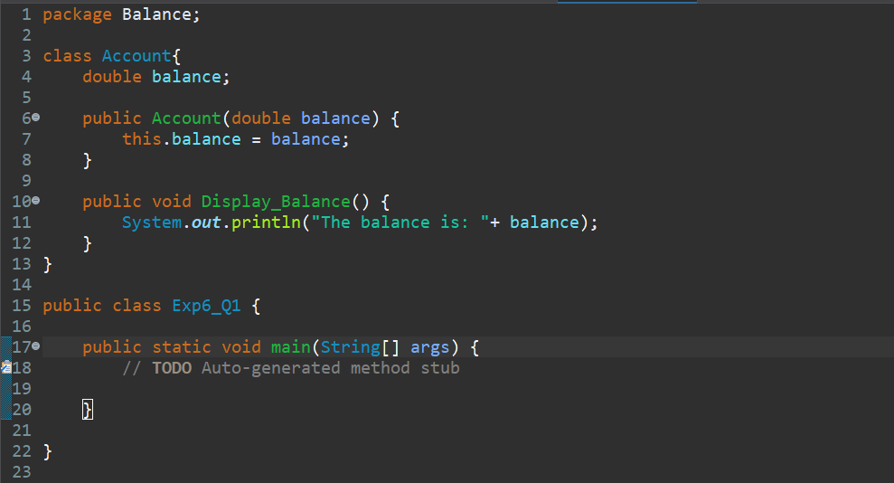
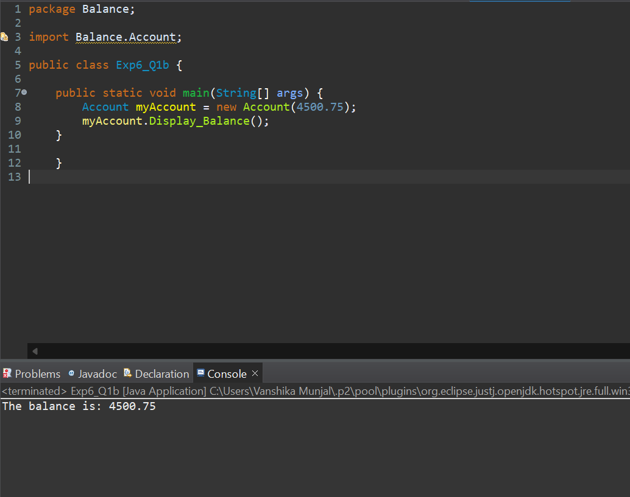

Ques 2. Create a package p containing a class A with four methods, each having different access modifiers (e.g., public, protected, default, and private). Write another class B in a different package Q with a main() method. Demonstrate how to access the methods of class A from class B, considering the access modifiers
Code :
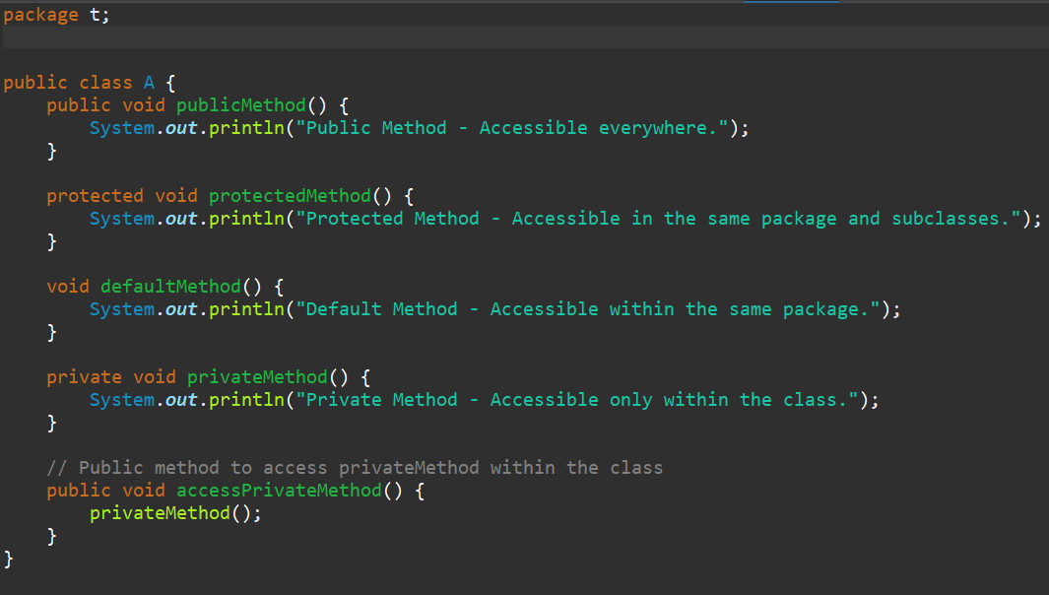
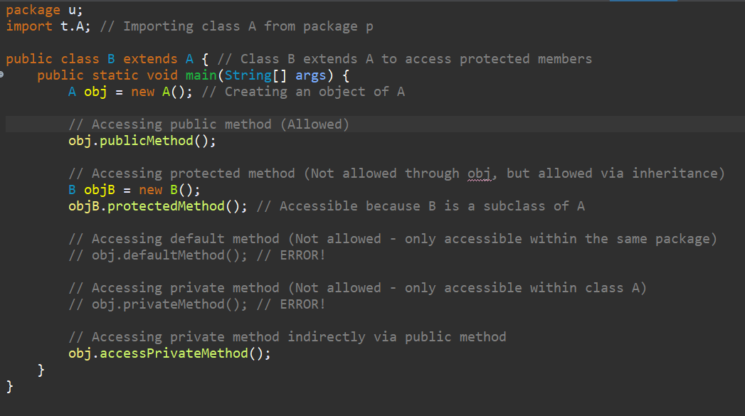
Output:
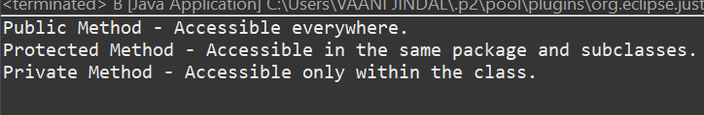
Ques 3: Write a Java program to demonstrate the use of the final keyword with a variable and a method. Create a class MathConstants with a final variable PI (value = 3.14159) and a final method displayPI() that prints the value of PI. Create another class Circle that extends
MathConstants and includes a method calculateArea(double radius) to calculate and print
the area of a circle using the formula: area = PI * radius * radius. In the main() method (in a separate class or Circle), test the calculateArea() method and observe the behavior when attempting to modify the PI variable or override the displayPI() method.
Code :
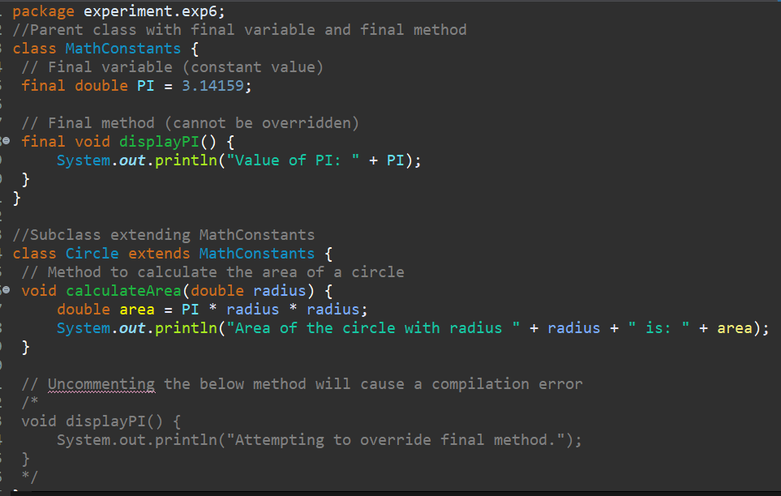
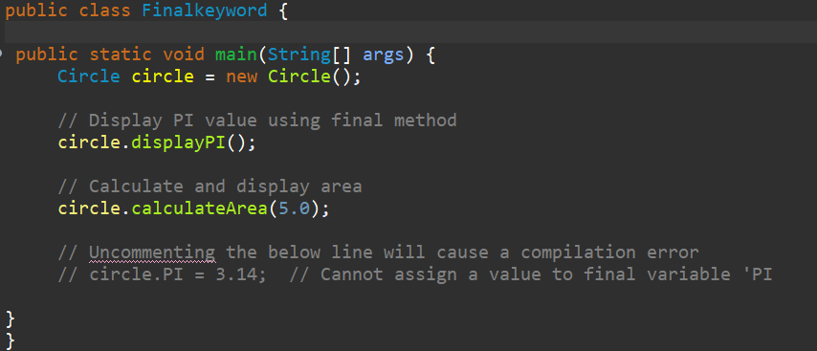
Output:
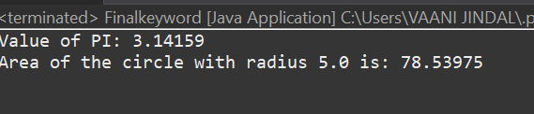
Ques 4: Write a Java program to demonstrate the use of the final keyword with a class. Create a final class Logger with a method logMessage(String message) that prints the message to the console. Attempt to create another class ExtendedLogger that extends the Logger class,
and observe and explain the result. In the main() method (in a separate class), create an object of the Logger class and call the logMessage() method to print a sample message.
Code :
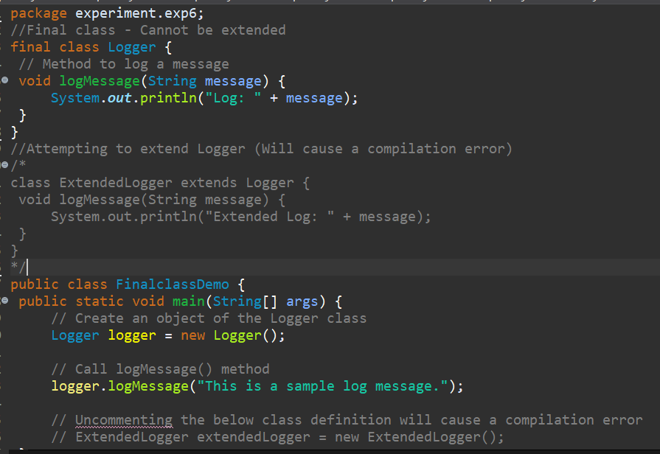

Output:
